GMB Extreme Features Report.
Increase Business or Sales by up to 15%.
Instantly using this report.
In this report I discuss the 3 Most New or Under Utilised Important OnPage GMB Features in 2020.
So we can drive more business, traffic, visitors to you and your Clients GMB’s and ultimately make more profits.

Table of Contents:
No1.
Get the “Request A Quote” button on your GMB Easily, right now for Free.
This is required for Service Area Listings.
No 2.
Questions and Answers Auto Suggest!!
No 3.
Increase your GMB’s number of “Followers” with an OFFER!!

No1. Get the “Request A Quote” button on your GMB Easily, right now for Free. [Top Of Page]
This is required for Service Area Listings.
Add a “Request a Quote” button to your Listing.
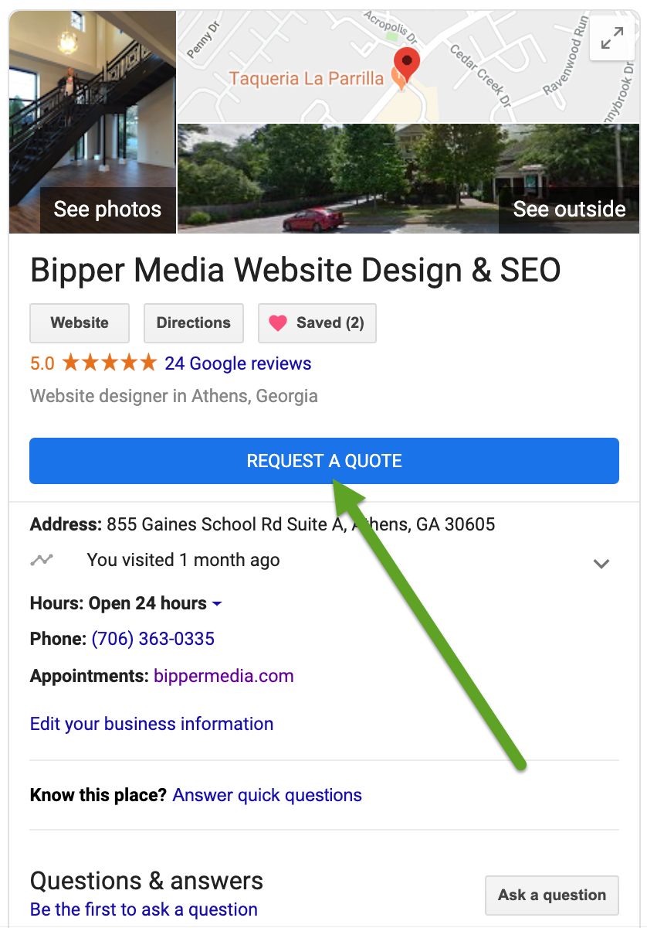
You can now add a button directly into your Google Listing, so people who come across your GMB can request a quote directly from your listing, for the service you provide and it appears directly on your phone in real time. Cool huh!!
To get this new feature activated, you need to do 2 things.
1. Install the Google My Business App on your Phone or Tablet.
Links to Apps here, Click/Tap on the appropriate image below.
IPhone:
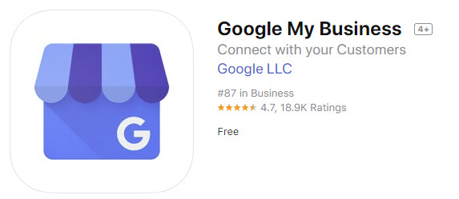
Tap on image to go to the direct download from Apple.
Android:
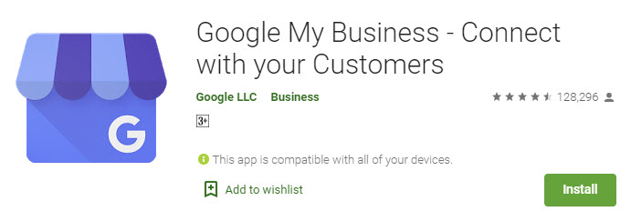
Tap on image to go to the direct download from Google Play.
Once you’ve installed it, log into the app using the same google account you use with your Google My Business Listing.
Once you are logged in, all your relevant information about your GMB listing will be presented to you, including activity, reviews reporting and TONS of other cool data, it’s great to spend as much time in this app to be able to enjoy all the features and data they present you, they’ve done an awesome job with this app.
The main thing to do now is to Enable the Messaging on the App.
To do this, tap on the “Customers” App at the bottom of the screen.
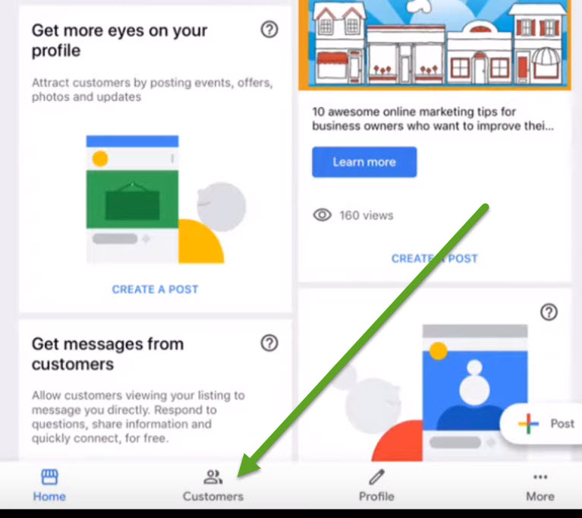

Once you click on the customers button, you’ll then see all your customer reviews in there.
At the top of the Screen, tap on the “Messages” Option.
Once you tap on the messages tab, you’ll be presented with this Option.
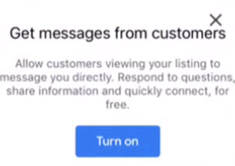

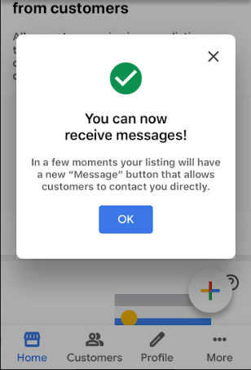

By turning on this feature this allows customers to contact you or the person managing this GMB in real time. Giving you the advantage to answer questions in real time and offer more information. To secure that sale. Completely Free.

After completing this step you will now see the
Request a Quote Button on your GMB Listing.
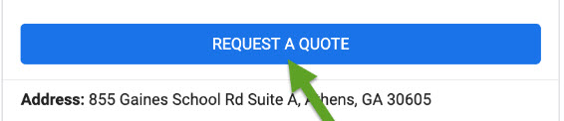

Then your prospects can submit a message directly to you, in real time like this.
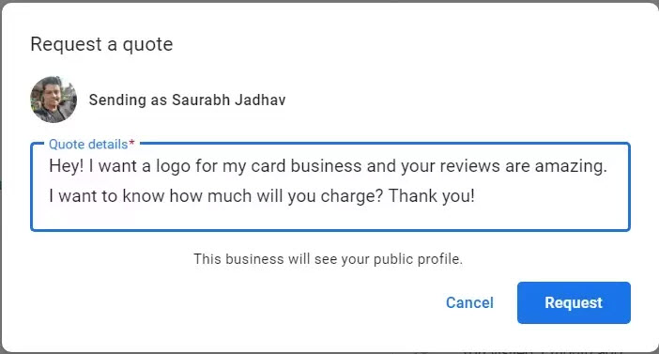
You will receive this in real time on your phone, allowing you to reply instantly securing your potential sale.
If you are like me and in a hurry, I contact a lot of service area business’s to do work around my acreage, and typically give the job to the first person who calls me back. Particularly for jobs that are urgent, after one of the many things around this joint breaks
It’s important to jump on this one right now, having this advantage over your competitors in the Local Listings space is a HUGE Advantage!!
No 2. Questions and Answers Auto Suggest!! [Top Of Page]
Just a few months ago, Google allowed people to ask questions directly to your Google My Business Listing.
I’m amazed at how few people in the GMB space know about this feature and it’s a doozy.
Most people are ignoring this and the advantage of being able to hack the auto suggestion replies.
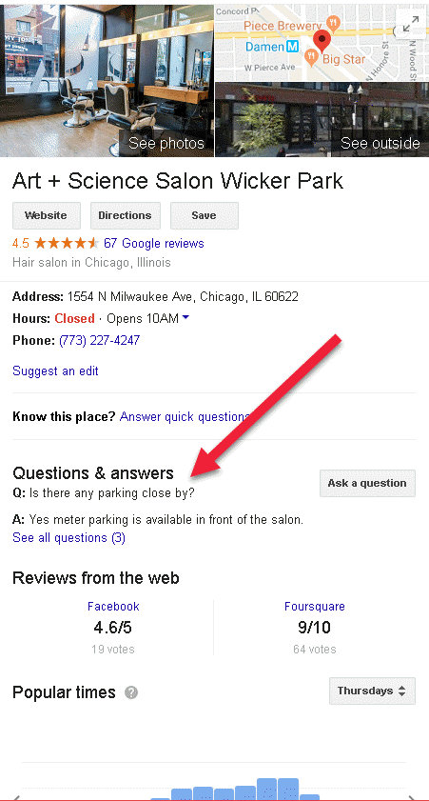

The great thing about this is, that typically the questions are very specific in relation to your business. So you are able to supply answers to generate a new lead or sale, completely automated, which is what we all love right
It’s amazing how many GMB’s I see with tons of unanswered questions, which could of lead to a ton more sales of course.
Google Now offers answers or tries to “Auto Answer” for you, from your previously answered questions, or existing customer reviews as well as your Google Posts.
So, here’s the fun bit, as a business owner, you already know the questions most likely to be asked.
Now you can create Posts on your GMB directly answering these questions or providing the solution people are looking for in each of your posts. Then Google will use these posts as auto suggested answers to questions your prospects are asking.
Create a list of specific questions that your customers typically ask you.
Then create one post per question. Your answer should have a CTA at the top of the post as this will be at the top of the auto suggested reply. Use incentives in your posts to encourage more business from these prospects typing in the questions.
This is why this is so Important to do right now.
I just selected a GMB, asked a question.
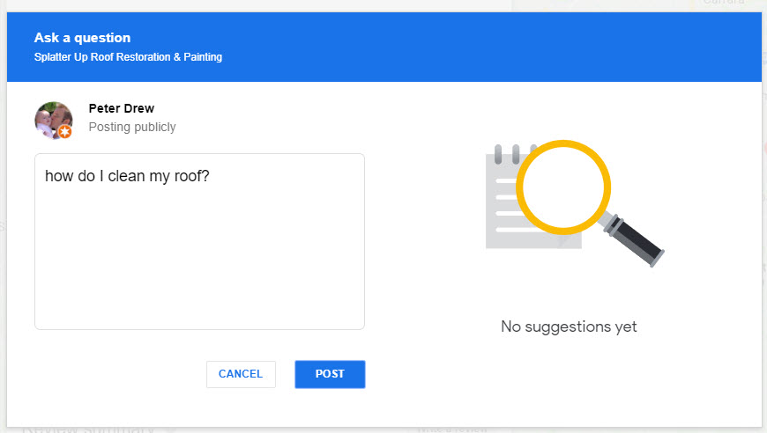
See on the right? There’s nothing, no help, nadda, zip.
So I guess I’ll move onto the next one who can provide an answer and hopefully an answer and price, then I’ll deal with that business instead of this one that is NOT setup to automatically answer any questions for me right now.
No 3. Increase your GMB’s number of “Followers” with an OFFER!! [Top Of Page]
Did you know? People can follow your Business on Google Maps?
This is one of the Lessor Known Features and it’s extremely cool.
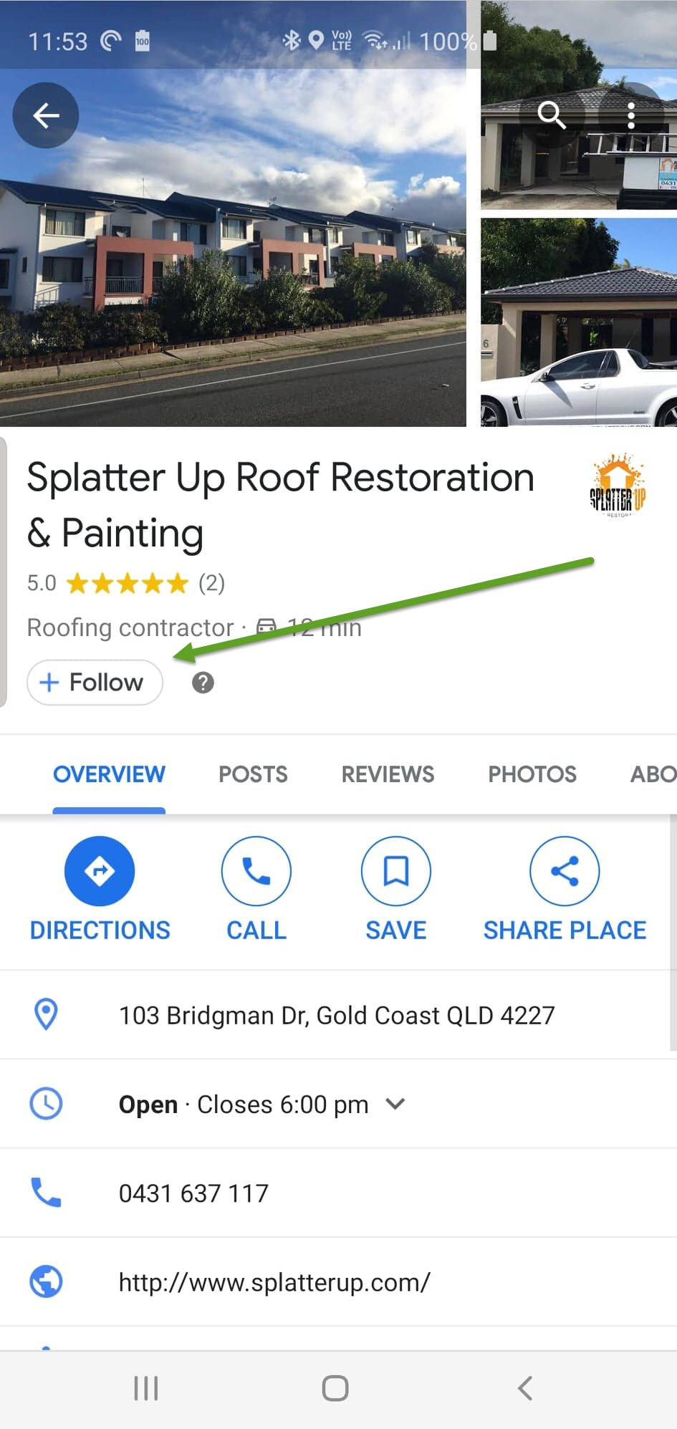
The follow button only appears on smart phones, not desktop etc.
When people follow you, they are made aware of each time you create a new post and do promotions. Meaning the more followers you have the more likely it is, that you’ll generate more business.
Your Promotions appear specifically in the “For You” button of your Google Maps App.
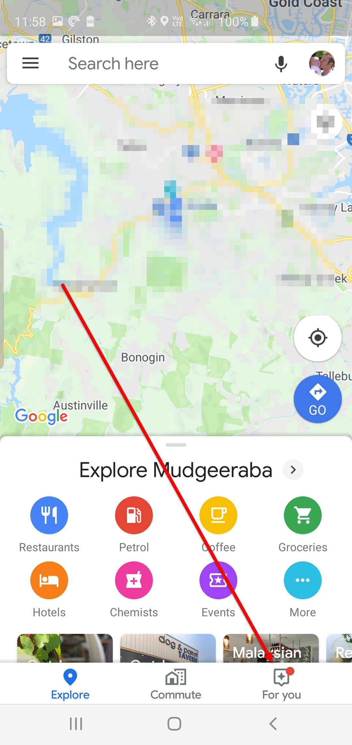
So each time you do a post or promotion in your GMB, it will appear in your followers “For You” section of Google Maps App.
This is NOT New, but what IS new is this.
The ability to create a “Welcome Offer” to Incentivise new visitors or existing customers to follow your Listing.
This is how you do it.
Open your Google My Business App ( links above )
Then tap on the Customers button at the bottom of the app.
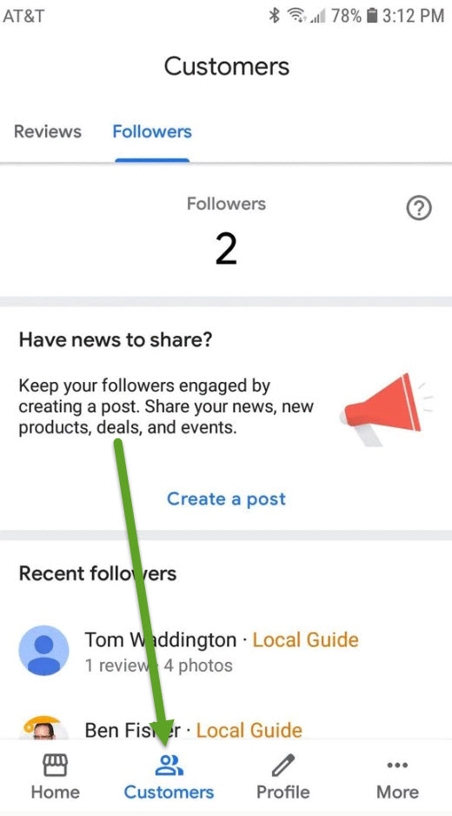

You should see your amount of existing followers in there.
Tap the Option
Create a Post
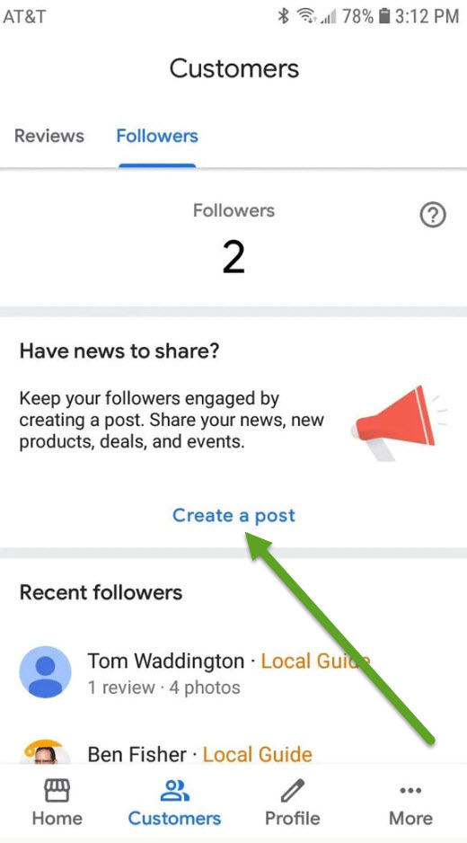

Then scroll through the middle section till you see the
Welcome Offer
Button then tap on it.
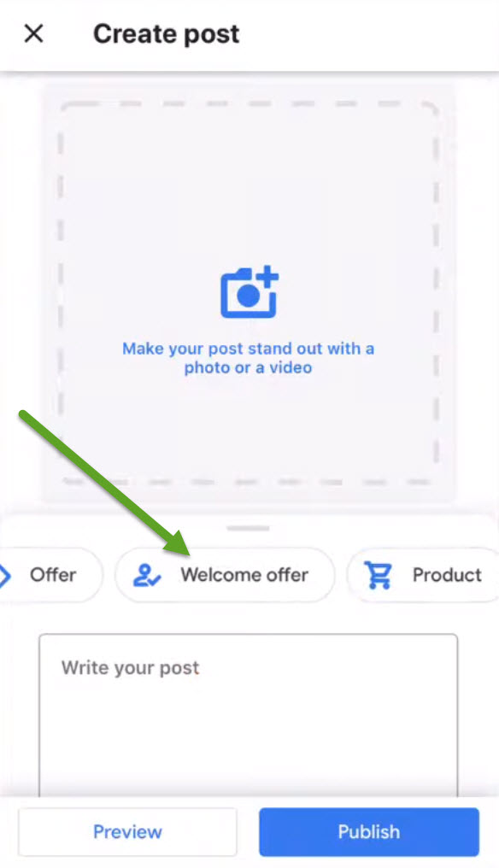

Create your Welcome Offer, Including an image.
The power is in the Image, here you can present your Ethical Bribe, a unique discount offer.
Then add your Title
Your Description
Terms and conditions.
Then click on Publish.
The next thing you need to do is encourage new or existing customers to follow you, so they are up to date on any new offers your company is providing, and this is the only place they can get your offers or deals.
You can do this by emailing your existing customers alerting them to new offers available via the app only. Publicize this on your website also. Plus you can create a post on your GMB alerting viewers to your special offers.
When you Follow someone in Google Maps App. The image the GMB owner setup is presented directly to you with the additional Save button. So if your offer is great, make sure you add
Tap to Save.
It just makes sense, that Google will give preference to those GMB’s who have proved to be more popular than the others surrounding it, if one GMB has a LOT more followers than it’s competitors, it makes sense that google will give preference to this GMB over the others who are not paying attention to their apps and responding to their market in real time. It’s googles job to present the most responsive business to its users.
So there you go Guys and Girls. I hope you’ve enjoyed this content.
Following the steps laid out will benefit your GMB listing immediately after you apply these strategies, and grow your GMB higher in the Rankings over time.

